Date: 03/03/2022

Lab Session No.: 03

**Aim:**

a)Develop an android application to demonstrate the Implicit and Explicit Intent.

b)Develop a mobile application that shares the message through an email.

**Software’s /IDE Tools:**

Android Development Kit / Android Studio

**Application User interface design:**

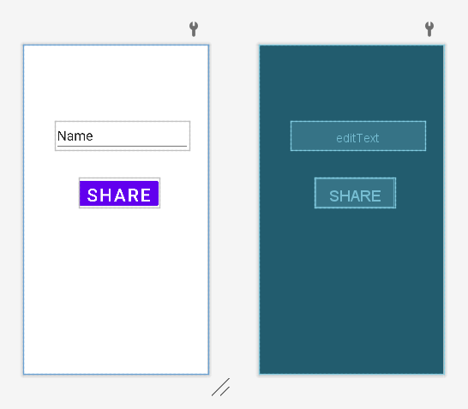

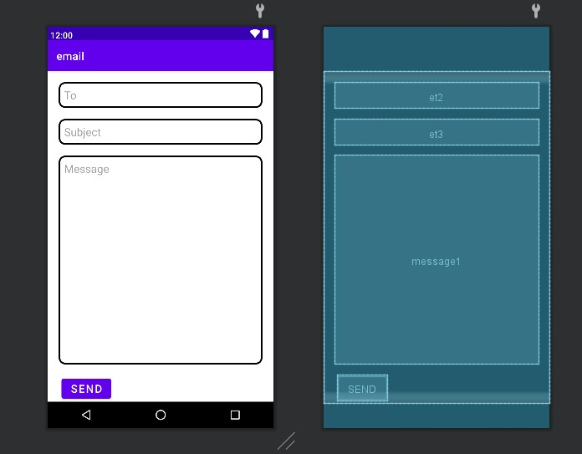

**Application Programming Interface:**

|  |  |  |  |
| --- | --- | --- | --- |
| **API / PACKAGES** | **CLASSES / INTERFACES** | **METHODS** | **DESCRIPTION** |
| import androidx.appcompat.app.AppCompatActivity; | AppCompatActivity | protected void onCreate(Bundle savedInstanceState) | onCreate(Bundle) is where you initialize your activity. When Activity is started and application is not loaded, then both onCreate() methods will be called. |
|  |  |
| import android.widget.EditText; | EditText | getText() | Determines the minimum type that getText() will return. If set, specifies that this TextView has a textual input method and should automatically capitalize what the user types. |

**Code/Implementation:**

// Develop an android application to demonstrate the Implicit and Explicit Intent.

// Project Name : ShareMyApp

/*

Lab Session No. : 03

Author : Tellakula Avinash

Date : 03/03/2022

Roll Number : 198W1A05C0

Description : Implementation of Intents

Softwares required : Android Studio

Topics Covered : Implicit Intents and Explicit Intents

*/

**a)MainAcitivity.java**

package com.avinash.myshareapp;  
  
import androidx.appcompat.app.AppCompatActivity;  
  
import android.os.Bundle;  
import android.view.View;  
import android.widget.EditText;  
import android.widget.Button;  
import android.content.Intent;  
  
public class MainActivity extends AppCompatActivity implements View.OnClickListener {  
  
 Button b;  
 EditText e;  
  
 @Override  
 protected void onCreate(Bundle savedInstanceState) {  
 super.onCreate(savedInstanceState);  
 setContentView(R.layout.*activity_main*);  
 b=(Button)findViewById(R.id.*button*);  
 e=(EditText)findViewById(R.id.*editText*);  
 b.setOnClickListener(this);  
 }  
  
 @Override  
 public void onClick(View v) {  
 if(v.getId()==R.id.*button*) {  
 String result=e.getText().toString();  
 Intent shareIntent=new Intent();  
 shareIntent.setAction(Intent.*ACTION_SEND*);  
 shareIntent.putExtra(Intent.*EXTRA_TEXT*,result);  
 shareIntent.setType("text/plain");  
 startActivity(shareIntent.*createChooser*(shareIntent,"Share to"));  
 }  
  
 }  
}

**activity_main.xml**

*<?*xml version="1.0" encoding="utf-8"*?>*<androidx.constraintlayout.widget.ConstraintLayout xmlns:android="http://schemas.android.com/apk/res/android"  
 xmlns:app="http://schemas.android.com/apk/res-auto"  
 xmlns:tools="http://schemas.android.com/tools"  
 android:layout_width="match_parent"  
 android:layout_height="match_parent"  
 tools:context=".MainActivity">  
  
 <EditText  
 android:id="@+id/editText"  
 android:layout_width="297dp"  
 android:layout_height="65dp"  
 android:layout_marginStart="72dp"  
 android:layout_marginTop="168dp"  
 android:ems="10"  
 android:inputType="textPersonName"  
 android:text="Name"  
 android:textSize="30sp"  
 app:layout_constraintStart_toStartOf="parent"  
 app:layout_constraintTop_toTopOf="parent" />  
  
 <Button  
 android:id="@+id/button"  
 android:layout_width="178dp"  
 android:layout_height="67dp"  
 android:layout_marginStart="124dp"  
 android:layout_marginTop="296dp"  
 android:text="Share"  
 android:textSize="40sp"  
 app:layout_constraintStart_toStartOf="parent"  
 app:layout_constraintTop_toTopOf="parent" />  
</androidx.constraintlayout.widget.ConstraintLayout>

**b)MainAcitivity.java**

package com.avinash.email;

import androidx.appcompat.app.AppCompatActivity;

import android.content.Intent;

import android.os.Bundle;

import android.view.View;

import android.widget.Button;

import android.widget.EditText;

public class MainActivity extends AppCompatActivity {

EditText mEditText,mEditTextMessage,mEditTextSubject;

Button send;

@Override

protected void onCreate(Bundle savedInstanceState) {

super.onCreate(savedInstanceState);

setContentView(R.layout.activity_main);

mEditText=(EditText)findViewById(R.id.et2);

mEditTextMessage=(EditText)findViewById(R.id.et3);

mEditTextSubject=(EditText)findViewById(R.id.message1);

send=findViewById(R.id.bt_send);

send.setOnClickListener(new View.OnClickListener() {

@Override

public void onClick(View v) {

sendMail();

}

});

}

private void sendMail(){

String getRecep=mEditText.getText().toString();

String[] getReceplist=getRecep.split(",");

String getsub=mEditTextSubject.getText().toString();

String getmsg=mEditTextMessage.getText().toString();

Intent intent=new Intent(Intent.ACTION_SEND);

intent.putExtra(intent.EXTRA_EMAIL,getReceplist);

intent.putExtra(intent.EXTRA_SUBJECT,getsub);

intent.putExtra(intent.EXTRA_TEXT,getmsg);

intent.setType("message/rfc822");

startActivity(intent.createChooser(intent,"Choose the appropriate channel"));

}

}

**activity_main.xml**

<?xml version="1.0" encoding="utf-8"?>

<LinearLayout xmlns:android="http://schemas.android.com/apk/res/android"

xmlns:app="http://schemas.android.com/apk/res-auto"

xmlns:tools="http://schemas.android.com/tools"

android:layout_width="match_parent"

android:layout_height="match_parent"

android:orientation="vertical"

tools:context=".MainActivity">

<LinearLayout

android:layout_width="match_parent"

android:layout_height="wrap_content"

android:orientation="vertical">

<EditText

android:layout_width="match_parent"

android:textSize="20dp"

android:id="@+id/et2"

android:layout_margin="20dp"

android:padding="10dp"

android:layout_height="wrap_content"

android:hint="To"

android:textColor="@color/black"

app:layout_constraintBottom_toBottomOf="parent"

app:layout_constraintLeft_toLeftOf="parent"

app:layout_constraintRight_toRightOf="parent"

android:background="@drawable/edit_text_background1"

app:layout_constraintTop_toTopOf="parent" />

<EditText

android:layout_width="match_parent"

android:textSize="20dp"

android:layout_marginLeft="20dp"

android:layout_marginRight="20dp"

android:padding="10dp"

android:textColor="@color/black"

android:id="@+id/et3"

android:layout_height="wrap_content"

android:hint="Subject"

app:layout_constraintBottom_toBottomOf="parent"

app:layout_constraintLeft_toLeftOf="parent"

app:layout_constraintRight_toRightOf="parent"

android:background="@drawable/edit_text_background1"

/>

<EditText

android:layout_width="match_parent"

android:textSize="20dp"

android:id="@+id/message1"

android:gravity="top"

android:textColor="@color/black"

android:layout_margin="20dp"

android:padding="10dp"

android:layout_height="380dp"

android:hint="Message"

app:layout_constraintBottom_toBottomOf="parent"

app:layout_constraintLeft_toLeftOf="parent"

app:layout_constraintRight_toRightOf="parent"

android:background="@drawable/edit_text_background1"

/>

<Button

android:layout_width="wrap_content"

android:layout_height="wrap_content"

android:id="@+id/bt_send"

android:layout_marginLeft="25dp"

android:text="Send"

android:textSize="20dp"

android:textColor="@color/white"/>

</LinearLayout>

</LinearLayout>

**edit_text_background1.xml**

<?xml version="1.0" encoding="utf-8"?>

<shape xmlns:android="http://schemas.android.com/apk/res/android"

android:shape="rectangle">

<stroke android:width="3dp"

android:color="@color/black"/>

<corners android:radius="10dp"/>

<solid android:color="@color/white"/>

</shape>

**Output:**

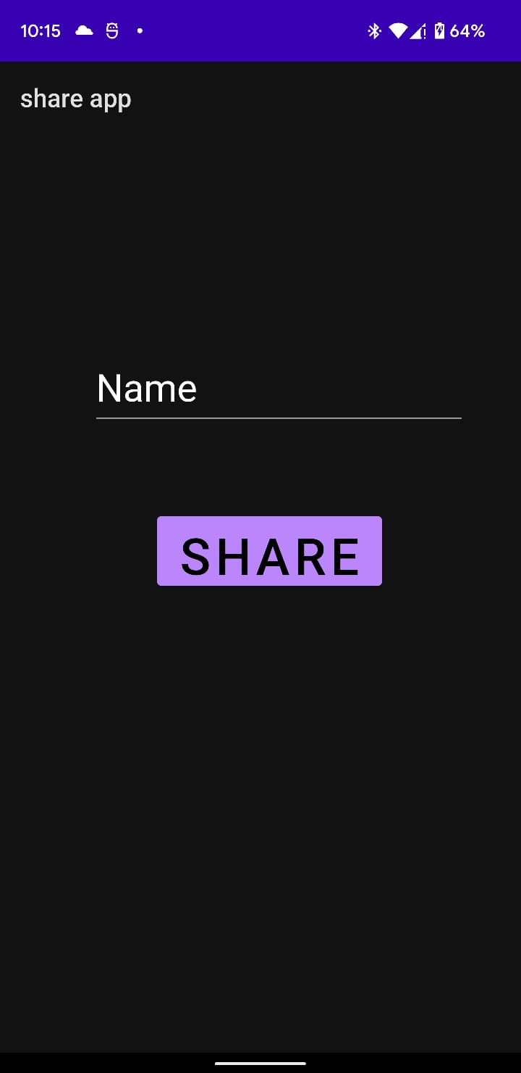 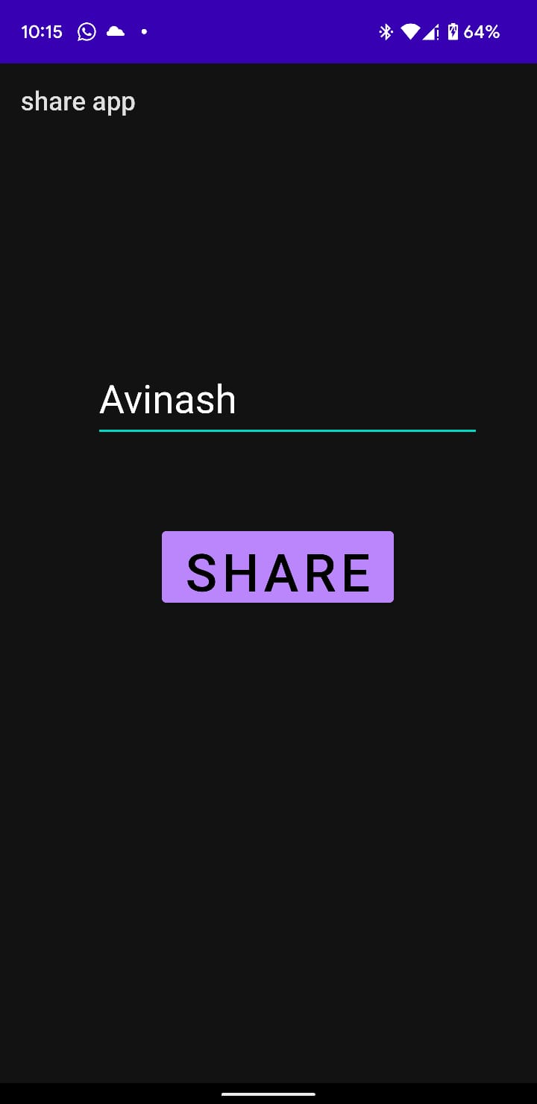

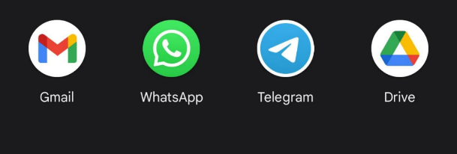

b)

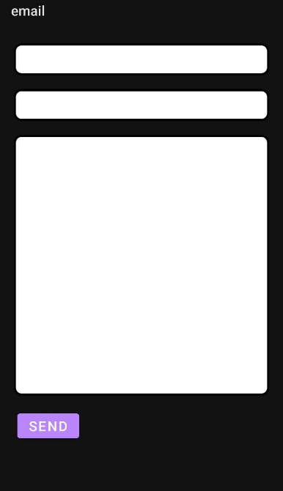 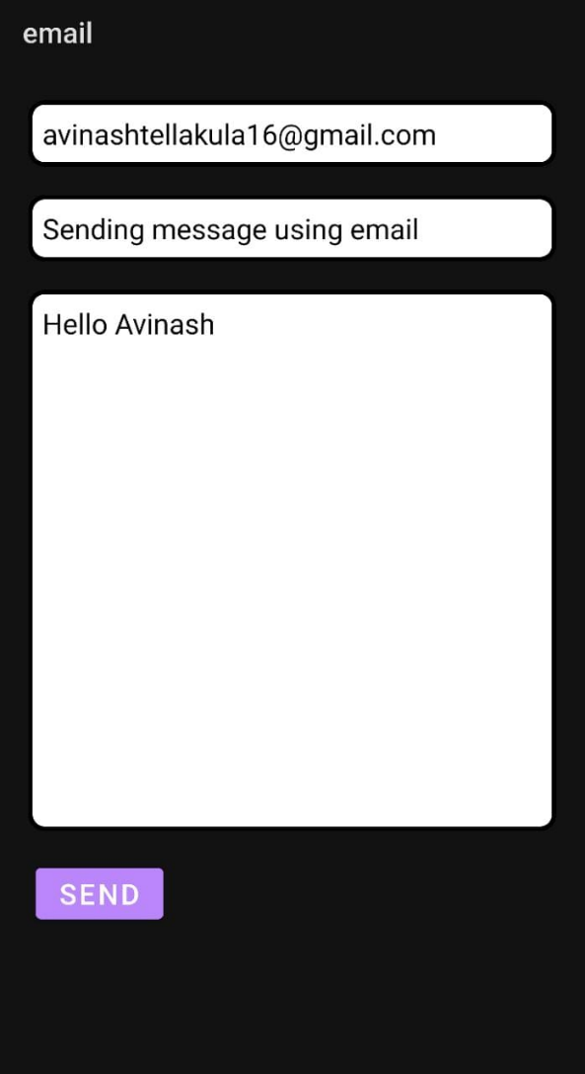



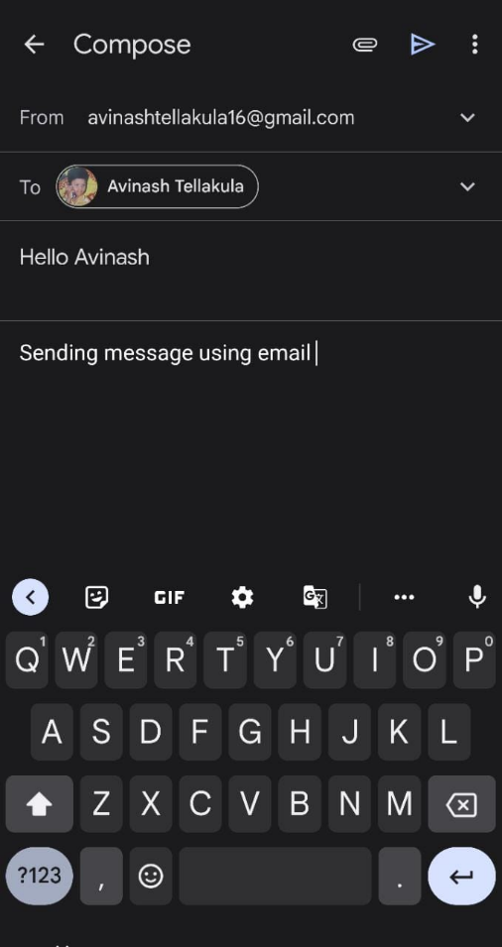 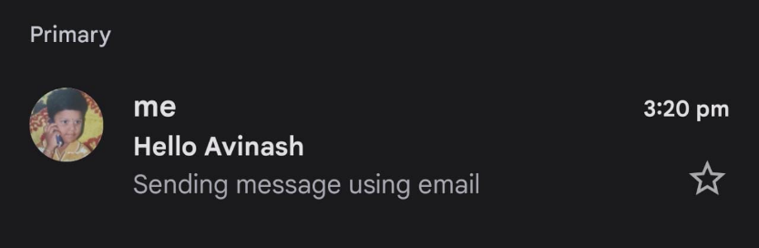

**Result:**

Demonstration the Implicit and Explicit Intents were done successfully.